

LICENSE SUMMARY

DATE: February 19, 2009

LICENSEE: Carmichael Lynch

ADDRESS: 110 North Fifth St. Minneapolis, MN 55403

CLIENT JOB#: 1SOAOO-0605-09

JOB NAME: Subaru 2009 March Sales Event TV

PRODUCTION TYPE: Commercial

VERSIONS: 2 Versions-“Imprezza” and “Outback”/Unlimited Dealer Tags

MEDIA: All

MARKET: National

TERRITORY: USA

TERM: One Month

START DATE: March 1, 2009

TOTAL FEES: $45,770

PAYMENT and PAYMENT SCHEDULE: Payment for the licensed content and related fees will be made to North River Entertainment prior to receiving the licensed content.

LICENSE AGREEMENT TERMS AND CONDITIONS: The licensed content is subject to the terms and conditions in the attached exhibits- exhibits-A, A2, B, C, D and D2.

DESCRIPTION OF LICENSED CONTENT:

FootageBank HD - Terms and Conditions attached in Exhibit A and A2

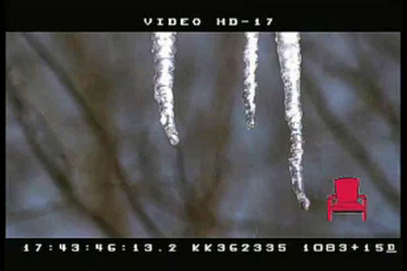 Icicles dripping
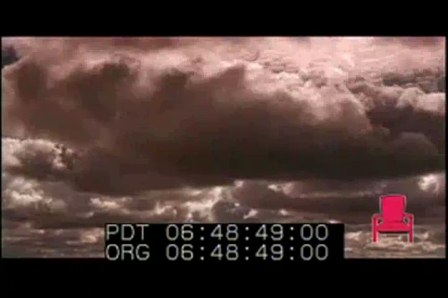 Dark storm clouds
 Aerial thru canyon over river

Third Millennium - Terms and Conditions attached in Exhibit B

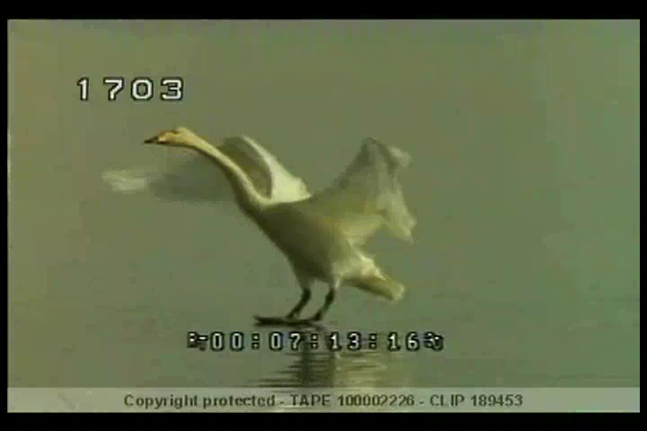 Goose Landing on Water
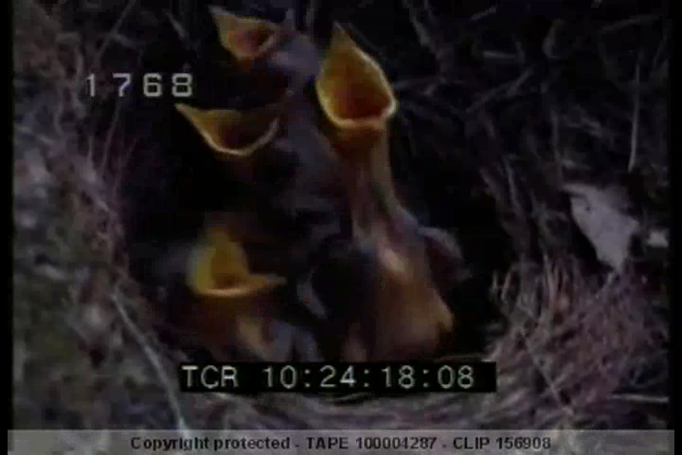 Baby Robins open mouths for food

Blacklight Films - Terms and Conditions attached in Exhibit C

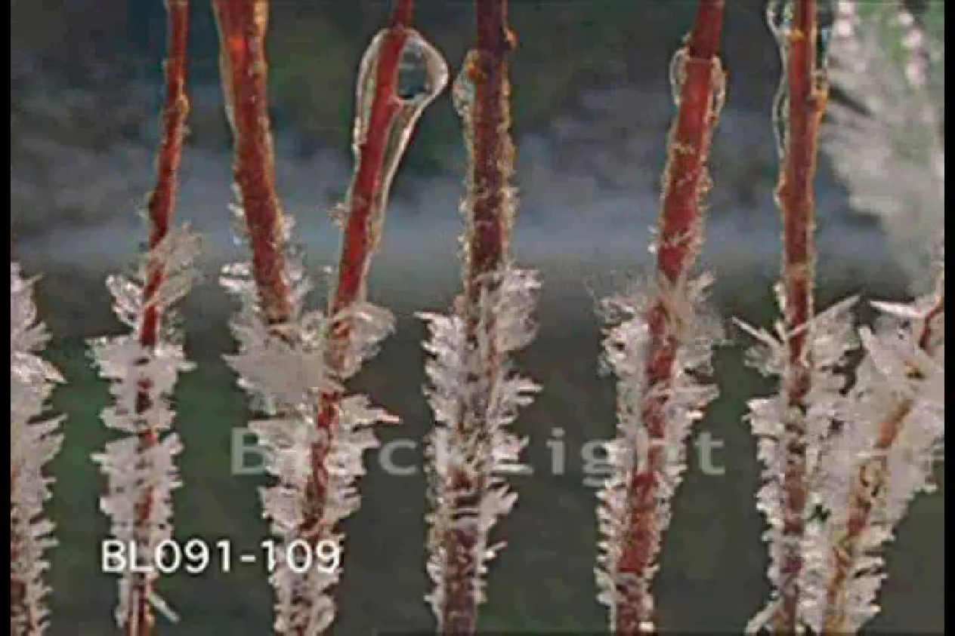 TL ice melting off plant stems
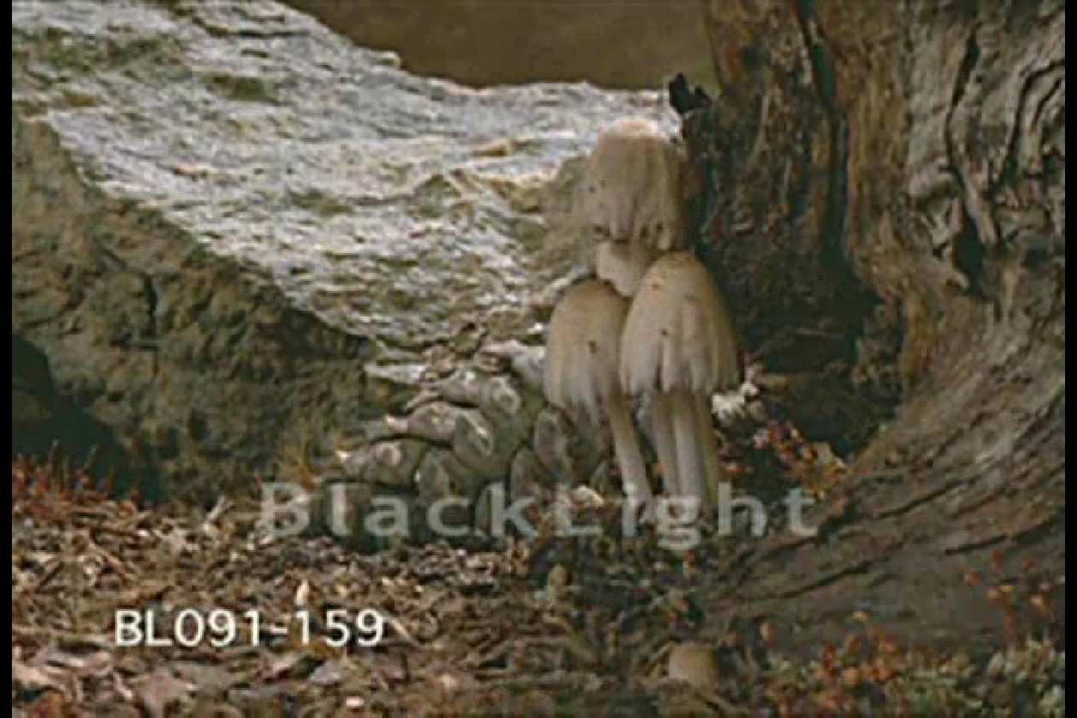 TL ice melting from tree bark & ground
 TL clovers blooming
 TL purple tulips open
Getty Images - Terms and Conditions attached in Exhibit D and D2

 T/L, CU yellow dahlia opening and closing
 SLO MO, ECU, Blue eye
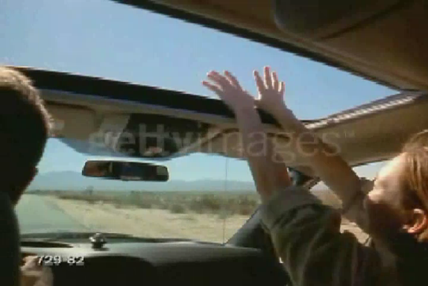 Woman stretching arms through sun roof
 Mountain bike through muddy water

